17.99: a) 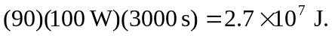
b) 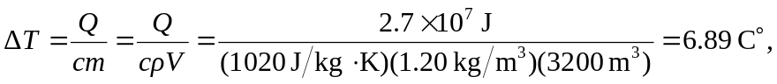
or 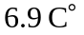 to the more apropriate two figures. c) The answers to both parts (a) and (b) are multiplied by 2.8, and the temperature rises by 